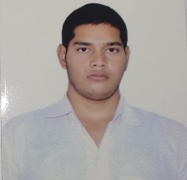Hemant Chaudhary

Vill – Radoi, Post:- Bisawar, Dist:- Mathura (Uttar Pradesh)

Contact no. :-7747873426,7906788891

Email:- [hemantchaudhary967@gmail.com](mailto:hemantchaudhary967@gmail.com)

D.O.B:- 03/05/2000

# Objective

I want to join an organization; a place where work culture is challenge and environment is competitive thus make an optimum utilization of my potential and give me the opportunity to improve my knowledge and experience. The organization growth is the main objective as it can help me to reach the pinnacle of my carrier and in growth through which I can enhance myself.

# Experience

Fresher.

# Education

10th Class:- **Board Of Secondary Education Madhya Pradesh.**

12th Class:- **Board Of Secondary Education Madhya Pradesh.**

Diploma in Computer Science and Engineering:- **RAJA BALWANT SINGH POLYTECHNIC, BICHPURI, AGRA**

# Awards and Acknowledgements

* I complete the N.C.C ‘A’ certificate.
* Certificate of DES (Data Entry Skills) Under N.S.D.C(National Skill Development Corporation) by NIIT.
* Certificate of Combined Annual Training Camp of N.C.C
* Certificate for participation for creating World Record for NCC for IDOY (International Day Of Yoga): 2015